1.Dijkstra’s algorithm

2.Huffman codes

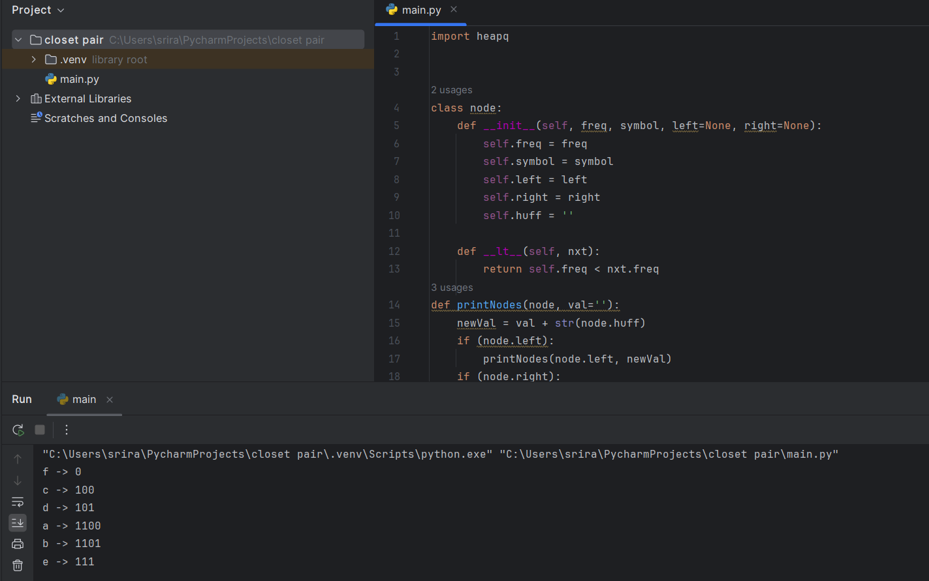

3.Container loading

4.Minimum spanning tree

5.Kruskal’s algorithm

6.Boruvka’s algorithm

